South Florida Growth Geographies: Data Summary
KTAF 2030 growth planning · June 2026 · Source: KIPP Demographics tool (Miami-Dade & Broward) unless noted
This summary covers the three targeted geographies for KTAF growth in South Florida: Miami-Dade Central (M-DCPS Board District 2 / Greater Liberty City), Miami-Dade South (M-DCPS Board District 9 / Greater Homestead), and Broward Central (BCPS Board District 5 / Greater Lauderhill). Each geography is presented on its own merits — the goal is to grow in all three.

County context
 | Broward County | Miami-Dade County
Actuals — U.S. Census Bureau (Vintage 2025)
Population, April 2020 | 1,944,376 | 2,701,762
Population, July 2025 | 2,013,317 | 2,802,029
Actual growth, 2020–2025 | +68,941 (+3.5%) | +100,267 (+3.7%)
Projections — BEBR medium series (Florida's official standard, Feb 2026)
Population, April 2025 (BEBR est.) | 1,993,535 | 2,814,927
Projected population, 2030 | 2,059,200 | 2,916,400
Projected growth, 2025–2030 | +65,665 (+3.3%) | +101,473 (+3.6%)
2030 range (BEBR low–high) | 1,953,500 – 2,164,800 | 2,766,800 – 3,066,000
K–8 population — ACS actuals and in-tool trend estimates
K–8 population (2023 ACS) | 204,343 | 268,019
Recent K–8 change, 2023→2025 (tool est.)* | −10,170 (−5.0%) | −13,296 (−5.0%)
Projected K–8 change, 2025–30 (tool est.) | −23,187 (−11.9%) | −30,347 (−11.9%)
* Rows marked “tool est.” are the demographics tool’s own trend extrapolations, not a published projection source — see Data Sources & Reliability. No primary source publishes projections at the board-district level (districts are not census geographies), so tool estimates are the only district-level option; treat them as directional.
Census actuals show both counties growing solidly from 2020 to 2025, and BEBR — the University of Florida bureau whose projections are Florida's official planning standard — projects continued growth through 2030 (+3.3% Broward, +3.6% Miami-Dade, medium series). The school-age population is the countertrend: ACS data show K–8 population already falling, actual public school enrollment (FL DOE) has declined every year since 2021–22, and the tool's trend estimates extend that decline through 2030. In short: South Florida's growth is concentrated among adults; the K–8 market is flat-to-shrinking even as total population rises, so enrollment growth will come from market share rather than market growth.

The three target geographies
 | Broward Central  BCPS D5 | Miami-Dade Central  M-DCPS D2 | Miami-Dade South  M-DCPS D9
Anchor communities | Greater Lauderhill | Greater Liberty City | Greater Homestead
Population, 2025 (proj.) | 284,811 | 312,372 | 319,090
Recent growth, 2023→2025 (tool est.)* | +3,079 (+1.1%) | +1,855 (+0.6%) | +3,810 (+1.2%)
Projected growth, 2025–30 (tool est.) | +3,168 (+1.1%) | +684 (+0.2%) | +3,229 (+1.0%)
K–8 population (2023 ACS) | 34,275 | 33,902 | 43,186
Recent K–8 growth, 2023→2025 (tool est.)* | −1,703 (−5.0%) | −1,676 (−4.9%) | −2,134 (−4.9%)
Projected K–8 growth, 2025–30 (tool est.) | −3,875 (−11.9%) | −3,795 (−11.8%) | −4,897 (−11.9%)
% Black (all ages) | 62.3% | 44.2% | 19.1%
% Hispanic (all ages) | 17.8% | 48.1% | 63.3%
% households under $50k HHI | 45.9% | 52.2% | 33.6%
% households receiving SNAP | 22.4% | 35.3% | 25.0%
Median household income (≈) | $62,100 | $55,700 | $86,300
Suitability score (tool default) | 83.8 · #1 of 7 | 70.0 · #1 of 9 | 67.3 · #2 of 9

What the numbers say about each geography
Broward Central (BCPS D5 / Greater Lauderhill) carries the top suitability score among Broward’s seven board districts (83.8 of 100). It is a majority-Black community (62%) with nearly half of households under $50k income and tool-estimated population growth of +1.1% through 2030. Its K–8 population — roughly 34,300 in the 2023 ACS — is shrinking with the region: down ~5% since 2023 and, on the tool’s trend estimate, falling from ~32,600 to ~28,700 (−11.9%) between 2025 and 2030.
Miami-Dade Central (M-DCPS D2 / Greater Liberty City) ranks #1 of Miami-Dade’s nine board districts on suitability (70.0). Economic need is pronounced — 52% of households under $50k and 35% receiving SNAP. Its K–8 population (roughly 33,900 in 2023) falls from ~32,200 to ~28,400 (−11.8%) between 2025 and 2030 on the tool’s trend estimate. Against that backdrop, charter enrollment grew 20% in four years while district-run enrollment fell 10%: a clear signal of unmet demand for alternatives.
Miami-Dade South (M-DCPS D9 / Greater Homestead) ranks #2 of Miami-Dade’s nine board districts (67.3). Greater Homestead pairs a large K–8 population — roughly 43,200 in 2023, falling to ~36,200 by 2030 on the tool’s trend estimate — with tool-estimated overall growth of +1.0% and a heavily Hispanic community (63%). Charters are well established here, enrolling about 36% of public school students with stable enrollment.

Enrollment: charter vs. district-run, 2021–22 to 2025–26
Public school enrollment is falling in each geography, consistent with the countywide school-age decline — but in each, charters are faring better than district-run schools. Charter figures below count currently operating schools only (matching InSite EFS methodology); see note at the end of this section. The tool’s enrollment series begins in 2021–22; 2020–21 is not available.
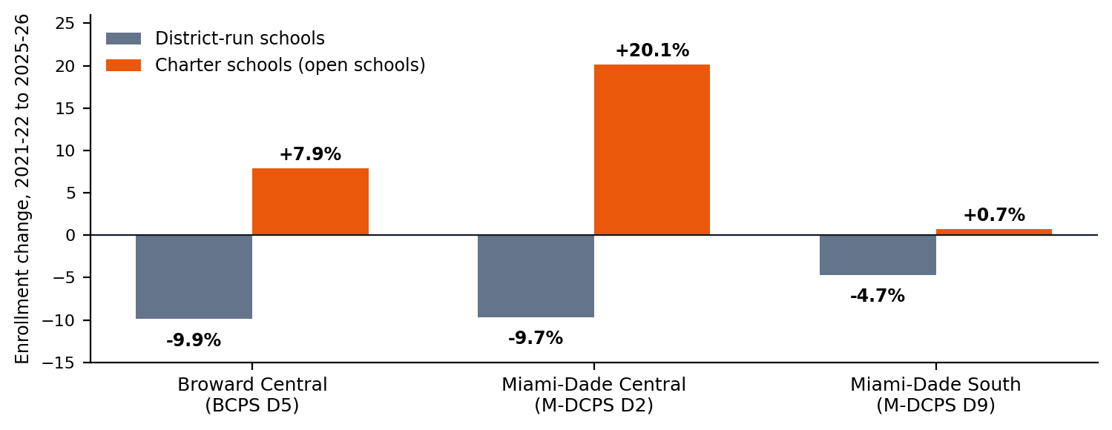
Broward Central (BCPS D5)
 | 2021–22 | 2025–26 | Change (n) | Change (%)
BCPS D5 — District-run (33) | 27,803 | 25,049 | −2,754 | −9.9%
BCPS D5 — Charter (4) | 2,738 | 2,955 | +217 | +7.9%
Miami-Dade Central (M-DCPS D2)
 | 2021–22 | 2025–26 | Change (n) | Change (%)
M-DCPS D2 — District-run (63) | 29,382 | 26,525 | −2,857 | −9.7%
M-DCPS D2 — Charter (13) | 3,976 | 4,775 | +799 | +20.1%
Miami-Dade South (M-DCPS D9)
 | 2021–22 | 2025–26 | Change (n) | Change (%)
M-DCPS D9 — District-run (46) | 32,291 | 30,767 | −1,524 | −4.7%
M-DCPS D9 — Charter (31) | 17,410 | 17,529 | +119 | +0.7%
Read: In D2, families leaving district-run schools are choosing charters — charter seats grew 20% while district-run enrollment fell 10%. In D5, district-run enrollment fell 10% while operating charters grew 8%; three small charters closed during the window (470 students in 2021–22), so quality of supply, not demand, has been the constraint there. In D9, charters hold a large, stable share of the K–8 market.
Method note: counting all charters that operated during the window — including the three D5 schools that later closed — total D5 charter enrollment declined from 3,208 to 2,955 (−7.9%). The open-schools view above matches InSite EFS and better reflects demand at operating schools.

Anchor school zoom-ins: the 5-minute drive-time view
District-wide figures can blend target neighborhoods with more affluent areas inside the same board district. The tables below zoom into a 5-minute drive time (≈1.8-mile radius in the tool) around one anchor school per geography, compared with the district-wide view. In each case, the immediate catchment shows more concentrated need than the district as a whole. The tool does not carry growth projections at the ring level; district-wide K–8 population is projected to decline roughly 12% from 2025 to 2030 in all three districts, and the catchments can be expected to track that trend.
William Dandy Middle — Fort Lauderdale (BCPS D5)
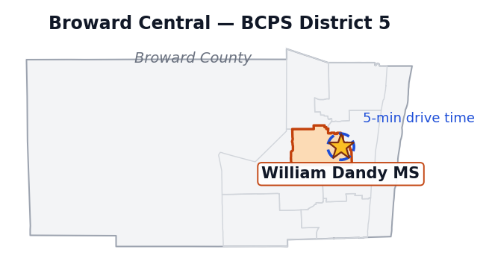 | 5-min drive District-wide  Population (2023 ACS) 69,772 281,732  K–8 population 9,627 34,275  % Black (all ages) 71.7% 62.3%  % Hispanic (all ages) 10.8% 17.8%  % households under $50k 43.2% 45.9%  % households on SNAP 27.1% 22.4%  Median household income (≈) $61,100 $62,100
The immediate Dandy catchment is more concentrated than the district-wide view suggests: 72% Black (vs. 62% district-wide) and 27% of households on SNAP (vs. 22%), with a K–8 population of roughly 9,600 within five minutes of the school.
Poinciana Park Elementary — Miami (M-DCPS D2)
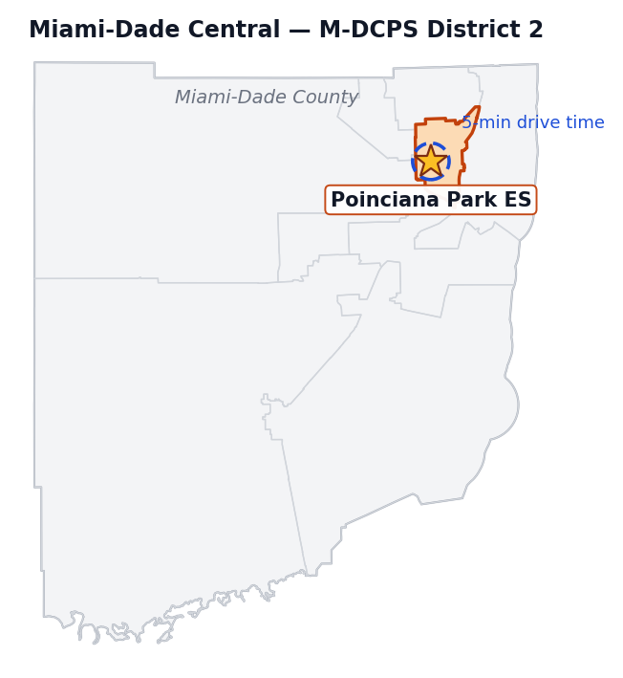 | 5-min drive District-wide  Population (2023 ACS) 76,846 310,517  K–8 population 9,068 33,902  % Black (all ages) 50.9% 44.2%  % Hispanic (all ages) 48.5% 48.1%  % households under $50k 56.8% 52.2%  % households on SNAP 44.0% 35.3%  Median household income (≈) $46,000 $55,700
The Poinciana Park catchment is needier on every measure: 57% of households under $50k (vs. 52% district-wide), 44% on SNAP (vs. 35%), and median income around $46,000 (vs. $55,700). D2 stretches northeast into coastal areas that soften the district-wide numbers.
Air Base K-8 — Homestead (M-DCPS D9)
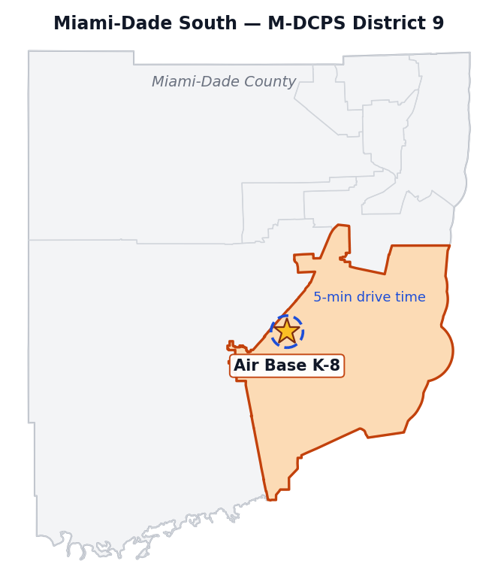 | 5-min drive District-wide  Population (2023 ACS) 45,199 315,280  K–8 population 6,628 43,186  % Black (all ages) 24.8% 19.1%  % Hispanic (all ages) 66.3% 63.3%  % households under $50k 37.1% 33.6%  % households on SNAP 31.4% 25.0%  Median household income (≈) $65,500 $86,300
The starkest gap of the three zoom-ins: the Air Base catchment’s median income is roughly $65,500 vs. $86,300 district-wide, and SNAP receipt is 6 points higher. D9 is geographically large, and its district-wide profile is pulled up by more affluent areas that are not the target community.

How the suitability score works
The tool’s suitability score is a 100-point weighted composite built from ten inputs. Each board district is scored against the other districts in its own county: for every input, the district at the county minimum gets 0 points, the district at the county maximum gets the full weight, and everyone else falls proportionally in between. Scores are therefore relative — a Broward score and a Miami-Dade score reflect standing within their own county, not a common scale. The default weights below were used throughout this document; the tool allows them to be adjusted.
Input | Weight | What it rewards
K–4th grade population | 20 pts | More elementary-age children
5th–8th grade population | 20 pts | More middle-grade children
% households with HHI below $50k | 10 pts | Higher economic need
% households receiving SNAP | 10 pts | Higher economic need
Black population (%), K–8 | 12 pts | Alignment with KIPP-served communities
Hispanic population (%), K–8 | 8 pts | Alignment with KIPP-served communities
Total population (2025) | 5 pts | Overall market size
5-year population growth (2025–2030) | 5 pts | Growing overall population
K–4th grade growth (2025–2030) | 5 pts | Growing elementary-age population
5th–8th grade growth (2025–2030) | 5 pts | Growing middle-grade population
In plain terms: 40 points for the size of the K–8 population, 20 for economic need, 20 for demographic alignment, and 20 for size and growth of the overall and school-age population.

Data sources and reliability
- Strongest sources (primary): county actuals from U.S. Census Bureau Vintage 2025 estimates; county 2030 projections from BEBR (UF Bureau of Economic and Business Research) Florida Population Studies Bulletin 203, Feb 2026, medium series — the projections Florida government uses for planning; current demographics from ACS 2023 5-year estimates; enrollment from FL DOE counts (2021–22 through 2025–26). Note BEBR’s April 2025 estimate differs slightly from the Census July 2025 estimate (different reference dates and methods); each series is shown self-contained, never mixed.
- Tool estimates (directional only): rows marked “tool est.” are produced inside the demographics tool, not by a published source. Total-population trends extrapolate the block-group change between ACS 2021 and ACS 2023 — overlapping 5-year windows the Census Bureau cautions against trending — and run well below BEBR (e.g., Broward 2025–30: +0.8% tool vs. +3.3% BEBR). They are retained only at the board-district level, where no primary source publishes projections.
- K–8 projection caveat: the tool’s grade-band trend applies the countywide FL DOE public-school-enrollment CAGR to the child population, which conflates families switching to private/ESA/homeschool options with actual population decline — so it likely overstates the K–8 drop. It also applies uniformly to every district, so districts differ in levels, not rates. A primary-source upgrade exists: BEBR/EDR publish county projections by age group (edr.state.fl.us), which should replace the tool’s county K–8 trend when extracted.
- Enrollment method: charter enrollment counts currently operating schools only, matching InSite EFS methodology (the D5 method note on page 3 quantifies the difference); school counts per sector appear in parentheses; schools were assigned to board districts by location against district boundaries.
- Geography notes: K–8 population is estimated from ACS age bands (ages 5–13), the same approximation ESRI uses. The 5-minute drive-time rings are radius approximations (≈1.8 miles), not road-network isochrones, can cross district and county lines, and carry no projections. Charter enrollment by district excludes charters just outside the district line that draw families from inside it.

